EtherCAT for JVL integrated servo motors

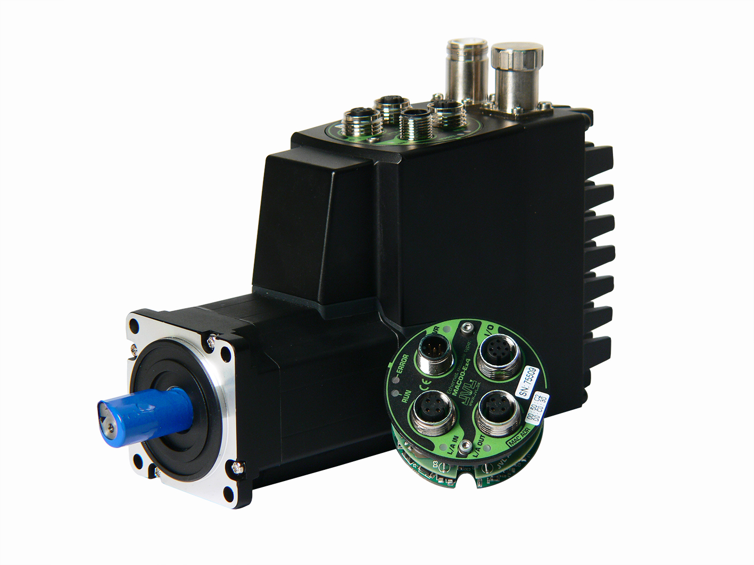
JVL is one of the leading companies in the field of integrated servo and stepper motors. For their medium power and new high power MAC motor’s, i.e. from 400 W to 3000 W, yet another expansion module has been added: The EtherCAT control module.
Beginning with BlueTooth and WLAN, JVL decided that established communication protocols in their expansion modules must be provided from well-known companies. This way, JVL can concentrate their efforts into the key area of developing leading integrated servo and stepper technology.
In the case of EtherCAT, the netX 50 series communication processor from Hilscher has been selected. One of the big advantages of this choice is that the expansion module hardware is the same no matter which Ethernet protocol is implemented thus minimizing the development time of e.g. EtherNet/IP, Profinet, Modbus TCP, Powerlink or Sercos III. Even future Ethernet protocols are supported as Hilscher develops drivers for them.

The EtherCAT module enables high speed real time Ethernet communication directly to the drives:
- 100 Mbit communication speed
- Response times in the sub-millisecond class
- 2 ports on the module offer Daisy-chaining possibility
- User friendly LED indicators
- Rough M12 connectors for industrial environment
- Option for 4 digital inputs, 2 digital outputs and 2 analogue inputs

For further information, please contact:
JVL Industri Elektronik A/S, Blokken 42, 3460 Birkerød, Denmark. Tel. +45 4582 4440. E-mail: jvlnyt@jvl.dk. Web: www.jvl.dk

